NAME : WIJAYAWARDHANA W.A.H.A.

REGISTRATION NO. : 2019/E/166

SEMESTER : SEMESTER 05

DATE ASSIGNED : 23 AUGUST 2022

DATABASE SYSTEMS – LAB 01

EC 5070

DATABASE SYSTEMS

Code:

CREATE DATABASE LAB01_166;

use LAB01_166;

CREATE TABLE EMPLOYEE

( Fname VARCHAR(15) NOT NULL, -- Adding columns

Minit CHAR,

Lname VARCHAR(15) NOT NULL, -- NOT NULL means the domain must have a value

Ssn CHAR(9) NOT NULL, -- CHAR padded to 9 spaces

Bdate DATE, -- Date, YYYY-MM-DD

Address VARCHAR(30), -- Variable length CHAR array (string)

Sex CHAR, -- Single character

Salary DECIMAL(10,2), -- Decimal up to a precision of two decimal points

Super_ssn CHAR(9),

Dno INT NOT NULL, PRIMARY KEY (Ssn));

-- Primary key constraint);

CREATE TABLE DEPARTMENT

(Dname VARCHAR(15) NOT NULL,

Dnumber INT NOT NULL,

Mgr_ssn CHAR(9) NOT NULL,

Mgr_start_date DATE,

PRIMARY KEY(Dnumber),

UNIQUE(Dname),

FOREIGN KEY(Mgr_ssn) REFERENCES EMPLOYEE(ssn));

CREATE TABLE DEPT_LOCATIONS

(Dnumber INT NOT NULL,

Dlocation VARCHAR(15) NOT NULL,

PRIMARY KEY(Dnumber,Dlocation),

FOREIGN KEY(Dnumber) REFERENCES DEPARTMENT(Dnumber));

CREATE TABLE PROJECT

(Pname VARCHAR(15) NOT NULL,

Pnumber INT NOT NULL,

Plocation VARCHAR(15) NOT NULL,

Dnum INT NOT NULL,

PRIMARY KEY(Pnumber),

UNIQUE(Pname),

FOREIGN KEY(Dnum) REFERENCES DEPARTMENT(Dnumber));

CREATE TABLE WORKS_ON

(Essn CHAR(9) NOT NULL,

Pno INT NOT NULL,

Hours DECIMAL(3,1) NOT NULL,

PRIMARY KEY(Essn,Pno),

FOREIGN KEY(Essn) REFERENCES EMPLOYEE(Ssn),

FOREIGN KEY(Pno) REFERENCES PROJECT(Pnumber));

CREATE TABLE DEPENDENT

(Essn CHAR(9) NOT NULL,

Dependent_name VARCHAR(15) NOT NULL,

Sex CHAR,

Bdate DATE,

Relationship VARCHAR(8) NOT NULL,

PRIMARY KEY(Essn,Dependent_name),

FOREIGN KEY(Essn) REFERENCES EMPLOYEE(Ssn));

INSERT INTO EMPLOYEE values

('Nipuna', 'B', 'Vishwajith', '112346523', '1999-04-04', '17, Main Street, TY', 'M', 150000, '123456789', 1),

('John', 'B', 'Smith', '123456789', '1955-01-09', '731 Fondren, Houston, TX', 'M', 30000, '987654321', 5),

('Franklin', 'T', 'Wong', '333445555', '1945-12-08', '638 Voss, Houston, TX', 'M', 40000, '888665555', 5),

('Joyce', 'A', 'English', '453453453', '1962-12-31', '5631 Rice, Houston, TX', 'F', 25000, '333445555', 5),

('Ramesh', 'K', 'Narayan', '666884444', '1952-09-15', 'Fire Oak, Humble, TX', 'M', 38000, '333445555', 5),

('James', 'E', 'Borg', '888665555', '1927-11-10', 'Stone, Houston, TX', 'M', 55000, NULL, 1),

('Jennifer', 'S', 'Wallace', '987654321', '1931-06-20', 'Berry, Bellaire, TX', 'F', 43000, '888665555', 4),

('Ahmad', 'V', 'Jabbar', '987987987', '1959-03-29', 'Dallas, Houston, TX', 'M', 25000, '987654321', 4),

('Alicia', 'J', 'Zelaya', '999887777', '1958-06-19', 'Castle, SPring, TX', 'F', 25000, '987654321', 4);

INSERT INTO DEPARTMENT values

('Research','5','333445555','1988-05-02'),

('Administration','4','987654321','1995-01-01'),

('Headquarters','3','888665555','1981-06-19'),

('Network','1','112346523','1989-08-01');

INSERT INTO DEPT_LOCATIONS values

('1','Houston'),

('4','Stafford'),

('5','Bellarie'),

('5','Sugarland');

INSERT INTO PROJECT values

('ProductX','1','Bellaire','5'),

('ProductY','2','Sugarland','5'),

('Computerization','10','Stafford','4'),

('Reorganization','20','Houston','1'),

('Newbenefits','30','Stafford','4');

INSERT INTO WORKS_ON values

('123456789','1','32.5'),

('123456789','2','7.5'),

('987654321','30','20'),

('333445555','20','10'),

('999887777','10','10');

INSERT INTO DEPENDENT values

('333445555','Alice','F','1986-04-05','Daughter'),

('333445555','Theodore','M','1983-10-25','Son'),

('987654321','Abner','M','1942-02-28','Spouse'),

('123456789','Alice','F','1988-12-30','Daughter');

SELECT * FROM lab01_166.employee;

SELECT Fname,Address

FROM lab01_166.employee

WHERE Salary > 30000;

SELECT Dname,Dlocation

FROM lab01_166.department , lab01_166.dept_locations

WHERE lab01_166.department.Dnumber = lab01_166.dept_locations.Dnumber;

SELECT Dlocation,Mgr_ssn

FROM lab01_166.dept_locations , lab01_166.department

WHERE lab01_166.dept_locations.Dnumber = lab01_166.department.Dnumber;

SELECT Dname,Fname

FROM lab01_166.DEPARTMENT , lab01_166.EMPLOYEE

WHERE lab01_166.DEPARTMENT.Mgr_ssn = lab01_166.EMPLOYEE.Ssn;

SELECT Fname,Dependent_name,Relationship

FROM lab01_166.EMPLOYEE , lab01_166.DEPENDENT

WHERE lab01_166.EMPLOYEE.Ssn = lab01_166.DEPENDENT.Essn;

SELECT Fname,Address

FROM lab01_166.EMPLOYEE

WHERE (Salary>25000) AND (Salary<50000);

SELECT Dname,Mgr_start_date,Dlocation

FROM lab01_166.DEPARTMENT,lab01_166.DEPT_LOCATIONS

WHERE lab01_166.DEPARTMENT.Dnumber = lab01_166.DEPT_LOCATIONS.Dnumber;

SELECT Pname,Dname,Dnumber

FROM lab01_166.PROJECT,lab01_166.DEPARTMENT

WHERE (lab01_166.DEPARTMENT.Dnumber = lab01_166.PROJECT.Dnum);

SELECT * , Dname

FROM lab01_166.EMPLOYEE , lab01_166.DEPARTMENT

WHERE (lab01_166.EMPLOYEE.Dno = lab01_166.DEPARTMENT.Dnumber) AND lab01_166.EMPLOYEE.Sex = 'F';

Screen Shots:

01.

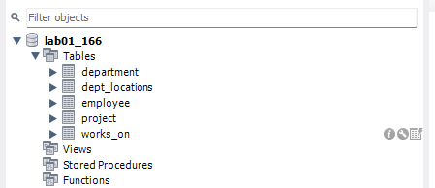

02.

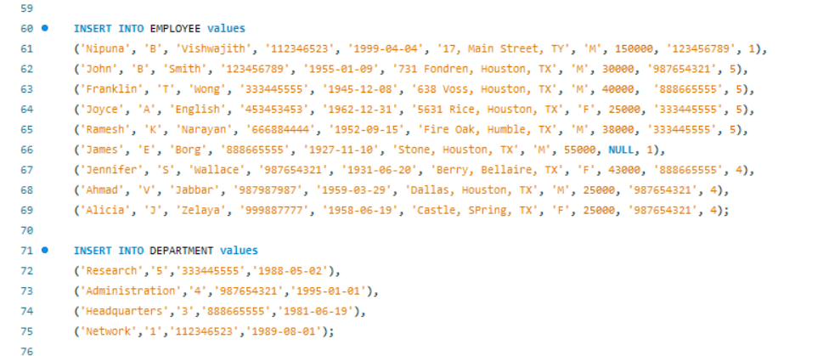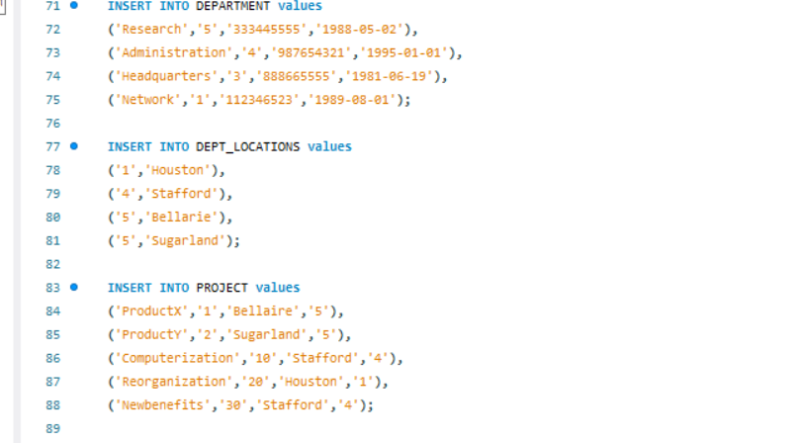

03.

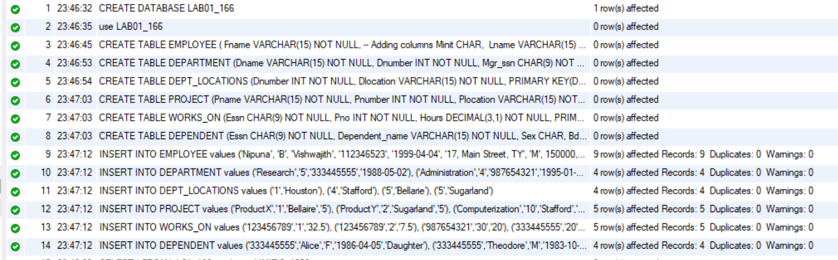

04.

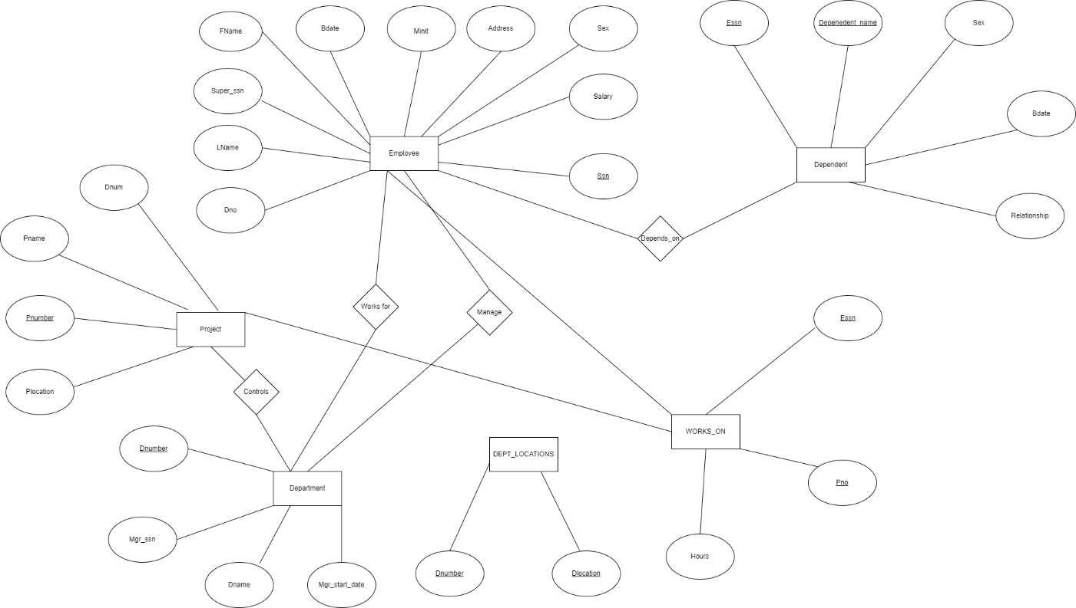

05.

a.

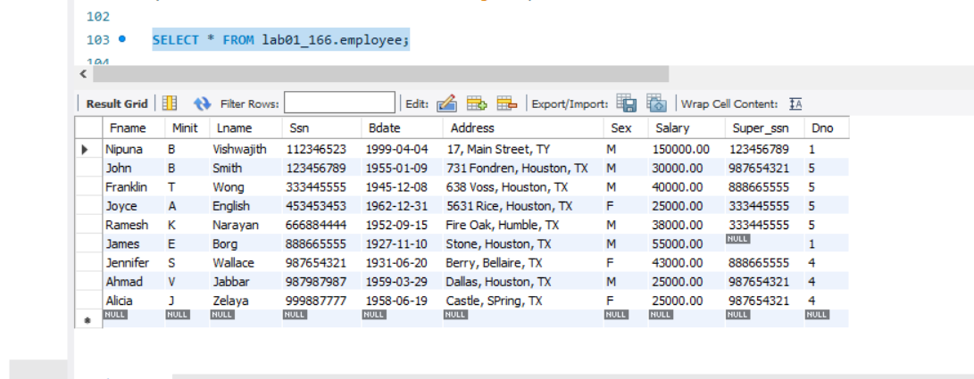

b.

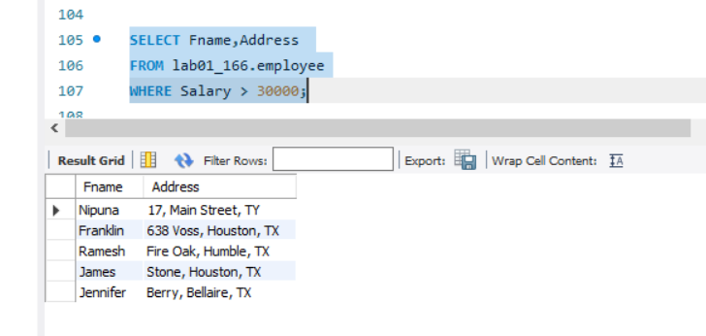

c.

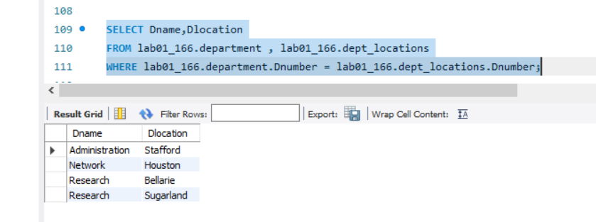

d.

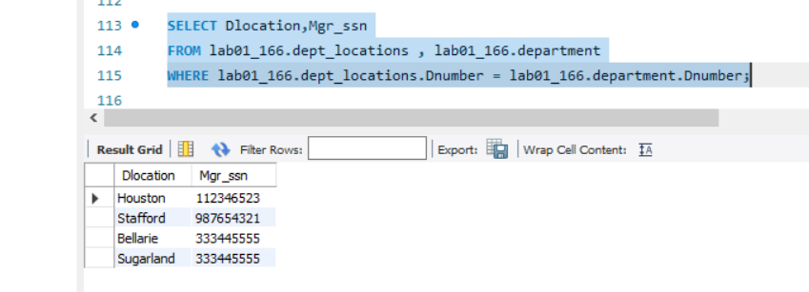

e.

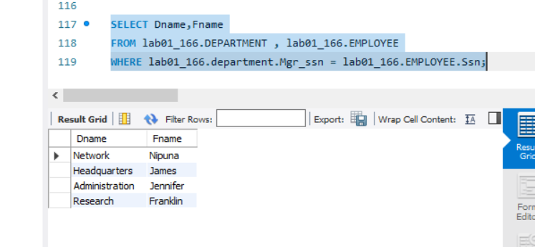

f.

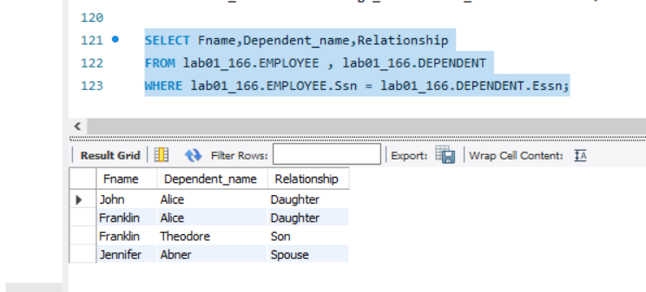

g.

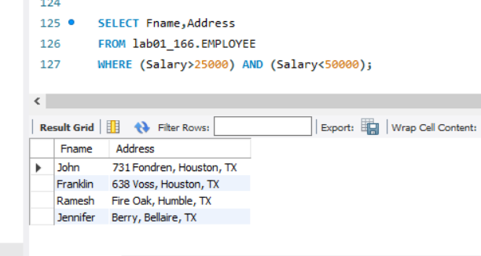

h.

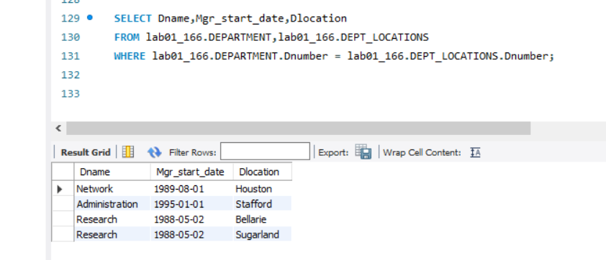

i.

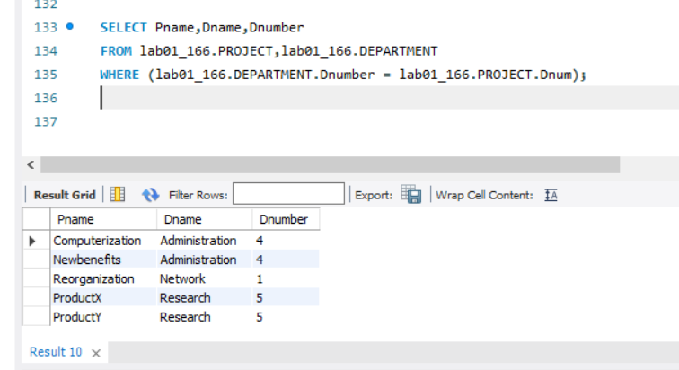

j.

